**Railway Reservation System**

**EXPERIMENT 6**

**Identify the use cases and develop Use case model with include and external relationships for the Railway Reservation System**

### **1. Understanding Use Cases**

A **Use Case** describes how a system interacts with users (or external systems) to achieve specific tasks. It includes:

* **Actors** (people or systems that interact with it, like passengers or admins).
* **Steps** showing how actors interact with the system.
* **Connections** between different use cases (e.g., some actions depend on others).

A **Use Case Diagram** is a visual way to show these interactions.

### **2. Actors in the Railway Reservation System**

**Actors** are the people or systems that use the railway system:

1. **Passenger (User)** – A person who books or manages train tickets.
2. **Admin** – A railway staff member who manages schedules, bookings, and cancellations.
3. **Payment Gateway** – A system that handles online payments.
4. **Bank System** – Manages transactions and refunds.

### **3. Use Cases in the Railway Reservation System**

#### ***A. Passenger Use Cases (User Actions)***

1. **User Registration & Login** – Passengers must sign up and log in before booking tickets. This includes verification (email, password, OTP).
2. **Search for Trains** – Users enter details like date, starting point, and destination to find available trains.
3. **View Train Details** – Users check train schedules, prices, seat availability, and routes.
4. **Book Ticket** (Main Action) – Users pick a train, choose a seat, and pay to confirm their booking.
   * **Select Seat** (A required step) – Passengers choose their preferred seat type (window, aisle, AC, sleeper, etc.).
   * **Payment Processing** (A required step) – Users pay online using credit/debit cards, UPI, or net banking.
5. **Cancel Ticket** – Users can cancel a booked ticket before the journey.
   * **Refund Processing** (A required step) – The system calculates the refund amount and processes it through the bank.
6. **Check PNR Status** – Users enter their Passenger Name Record (PNR) number to check if their ticket is confirmed.
7. **Print Ticket** – Users can download or print their e-ticket after booking.

#### ***B. Admin Use Cases (Admin Actions)***

1. **Manage Train Schedules** – Admins can add, update, or cancel train schedules. This affects ticket availability.
2. **Cancel Ticket (Admin Override)** – In special cases (like train delays), admins can cancel tickets.
3. **Generate Reports** – Admins can create reports on bookings, cancellations, and revenue.

### **4. Relationships Between Use Cases**

#### ***A. "Include" Relationship (Required Steps)***

Some actions **must** happen for another action to work. For example:

* **"Book Ticket" includes "Payment Processing"** → You can’t book a ticket without paying.
* **"Cancel Ticket" includes "Refund Processing"** → If you cancel a ticket, the system must process a refund.

#### ***B. "Extend" Relationship (Optional Steps)***

Some actions **only happen in special cases**:

* **"Admin Cancel Ticket" extends "Cancel Ticket"** → Admins can cancel tickets in exceptional cases.
* **"Manage Train Schedules" extends "Book Ticket"** → If a train schedule changes, it can affect ticket bookings.

**5. Use Case Diagram Representation**

A **Use Case Diagram** visually represents actors and system interactions.

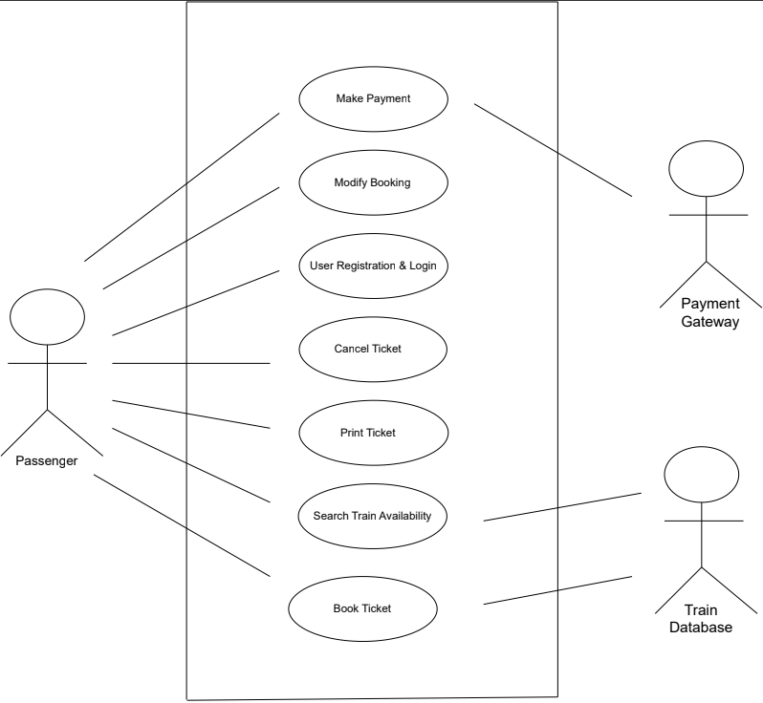

**Use Case of Railway Reservation System**